**Task 1**

**Installation of Cisco Packet tracer**

Step 1: Open any web browser and type for cisco packet tracer net cad

Step2: Click on the first link and make sure you login with your student mail id.

Step3: Now inside the web page click on Getting Started with cisco packet tracer

Step4: After clicking on that then click on self-paced learning

Step5: Now scroll down upto the download chapter

Step6: In the download chapter you can see the download icon and under that you can see a link.

Step7: Once you click the link the Cisco packet tracer will be downloaded.

Step8: After finishing the download just open the file and click the next option until installation is complete.

Step9: Once the installation is complete you can see a back option but don’t click on it, instead click on all skills option in the green box.

Step10: You might be asked again to login or not, once its done the installation is complete and its open to use.

**Task 2**

**Execute the following network commands like ipconfig, tracert, telnet, ping, nslookup, netstat**

**Procedure:**

**Step 1:** Launch CISCO packet tracer; double click the cisco packet tracer icon on your desktop or find it the search bar or applications list and open the program.

**Step 2:** Create a simple network topology

1. Add devices

Drag and drop a router and switch from the device list on to the workspace

Drag and drop 2 PC’s on to the workspace

1. Connect devices:

Use the connection tool to connect the devices

* Connect one PC to the switch using the Copper Straight-Through cable
* Connect the switch to the router using another Copper Straight-Through cable
* Connect the second PC to the switch using Copper straight-Through cable

1. Configure devices:

* Configure the router:
* Click on the router
* Go to config tab
* Assign IP address to the router interfaces

**Ex:**

1. [PC0]

Interface G0/0/0

IPv4 add = 192.168.1.1

Subnet mask = 255.255.255.0

1. [PC1]

Interface G0/0/1

IPv4 add = 192.168.2.1

Subnet mask = 255.255.255.0

1. Configure the PC’s:

* Click on each PC
* Go to the desktop option
* IP configuration
* Assigning IP addresses to each PC

Ex:

1. [PC0]

IP: 192.168.1.2

Subnet mask = 255.255.255.0,

Default gateway = 192.168.1.1

1. [PC0]

IP: 192.168.2.2

Subnet mask = 255.255.255.0,

Default gateway = 192.168.2.1

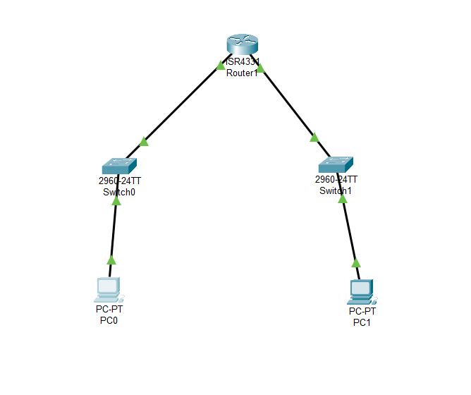

**Step 3:** Execute networking commands

1. **Command ipconfig:**

This command displays all current tcp ip network configurations values and all DHCP and DNS settings.

Open the command prompt of PC0:

* Click on PC0
* Go to the desktop tab
* Open the command prompt
* Type command **ipconfig**

**Output:**

* Follow the same steps for PC1: The output will be

1. **Command tracert:**

This command traces the path taken to a destination by sending ICMP echo request messages

**Step1:**

* Click on PC0
* Go to desktop tab
* Open the command prompt

Commnad: tracert 192.168.2.2

**Output:**

1. **Command telnet:**

Telnet is an unencrypted protocol and is not secure. For real-world applications, consider using SSH to secure remote connections.

**Step1:**

* Click on the router
* Go to the config tab
* Select the interface connected to the switch (e.g. G0/0)
* Assign IP address 192.168.1.1, Subnet mask: 255.255.255.0
* Open the CLI and type exit until you get this

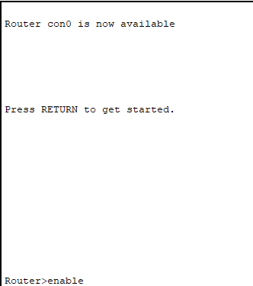

* Once you get this type all these commands:

Router>enable

Router#configure terminal

Enter configuration commands, one per line. End with CNTL/Z.

Router (config) #line vty 0 4

Router (config-line)#password cisco

Router (config-line)#login

Router (config-line)#exit

Router (config-line)#exit

Router (config)#end

Router#

\SYS-5-CONFIG_I: Configured from console by console

Router#write memory Building configuration...

[OK]

Router#

**Reference image to write the commands**

**Step2:**

* Now open the Command prompt of PC0
* Click on the PC0
* Click on the desktop
* Then click on the command prompt
* Enter the command: telnet 192.168.1.1
* You can see the password: type cisco

Your command execution is completed

**Output:**

**Router configuration and brief ip interface:**

* **Note:** This should be done in the CLP (Command line interface) of the router

**Command:** show ip interface brief

**Output:**

1. **Command ping:**

The ping command is used to **test network connectivity** between two devices. It checks if one device (like a PC) can reach another device (like a router, server, or website) and measures how long it takes.

* Click on the PC0
* Click on the desktop
* Click command prompt
* Type the following command
* Command: ping 192.168.2.2

**Output:**

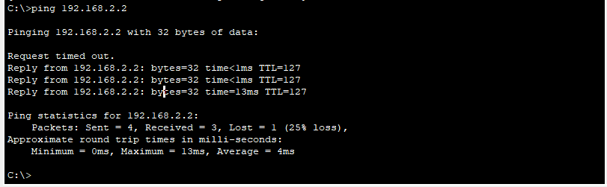

1. **Command nslookup:**

This command queries the DNS to obtain domain name or IP address maping.

To use the nslookup command to resolve a domain name to an IP addressin Cisco Packet Tracer, you’ll need to ensure that the DNS server is properly configured in your netwok topology.

**Step 1:** Add one server (to act as a DNS server).

**Step2:** Connect both PCs and the server to the switch using copper straight-through cables.

Configure the DNS Server

1. Assign IP Address:

* Click on the server.
* Go to the Config tab and select the FastEthernet0 interface.
* Assign

IP address: 192.168.1.3,

Subnet Mask: 255.255.255.0,

Default Gateway: 192.168.1.1.

Configure DNS Service:

* Go to the Services tab on the server.
* Select DNS and turn the service On.
* Add an entry for www.google.com with an IP address (e.g., 8.8.8.8).
* Use the nslookup Command

**Step3:** Open Command Prompt on PCO:

* Go to the Desktop tab on PCO.
* Open the Command Prompt. 2.
* Execute the nslookup
* Command: nslookup www.google.com

**Output:**

1. **Command netstat:**

* This command displays network connections for the Transmission Control Protocol (TCP), routing tables, and a number of network interface and network protocol statistics.
* The netstat command is used to display network connections, routing tables, interface statistics, masquerade connections, and multicast memberships.

**DNS Server Configuration:** Ensure that the DNS server is correctly configured and running.

**DNS Entries:** The DNS entry for www.google.com should be added to the DNS server with an IP address.

**Network Configuration:**

Ensure that all devices are correctly connected and configured with appropriate IP addresses, subnet masks, and default gateways.

